Sequence-Based Synesthesia

🧠🔢 What is Sequence-Based Synesthesia?
# Source: Chatgpt (GPT-4-turbo) at [7/24/2025]
Sequence-based synesthesia is a group of synesthesia types in which ordered sequences (like numbers, days, letters, months, or years) trigger unusual sensory or mental experiences — such as colors, personalities, or spatial arrangements.

📘 Definition:
# Source: Chatgpt (GPT-4-turbo) at [7/24/2025]
Sequence-based synesthesia refers to forms of synesthesia in which ordinal sequences (like "Monday, Tuesday", or "A, B, C") consistently and involuntarily produce extra experiences, such as visual shapes, spatial locations, or person-like traits.

🧩 Common Types of Sequence-Based Synesthesia:
# Source: Chatgpt (GPT-4-turbo) at [7/24/2025]
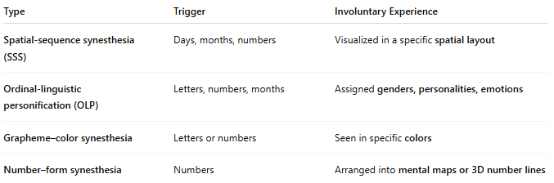
Type | Trigger | Involuntary Experience
Spatial-sequence synesthesia (SSS) | Days, months, numbers | Visualized in a specific spatial layout
Ordinal-linguistic personification (OLP) | Letters, numbers, months | Assigned genders, personalities, emotions
Grapheme–color synesthesia | Letters or numbers | Seen in specific colors
Number–form synesthesia | Numbers | Arranged into mental maps or 3D number lines

🧠 Why It Happens:
# Source: Chatgpt (GPT-4-turbo) at [7/24/2025]
Sequence-based synesthesia is believed to involve:
- Cross-activation in the brain between:
  - Ordinal processing areas (which understand sequences)
  - Visual, spatial, or social cognition areas
- It is usually genetic and develops early in life

🧒 Example from a Synesthete:
# Source: Chatgpt (GPT-4-turbo) at [7/24/2025]
"When I think of the number 7, it’s not just a number — it appears to the right of 6 in a sloping arc, and it feels like a calm, wise person. Monday is light blue and stands above Tuesday."
This could include:
- SSS (numbers in spatial arc)
- OLP (7 is a wise person)
- Grapheme–color (Monday is light blue)

✅ Summary:
# Source: Chatgpt (GPT-4-turbo) at [7/24/2025]
Sequence-based synesthesia is when sequential concepts like days, numbers, or letters trigger extra experiences — such as seeing them in space, giving them colors, or assigning them personalities.
It's consistent, automatic, and highly individual.

